iterations = 2500
learning_rate = 0.1
hidden_nodes = 10
output_nodes = 1
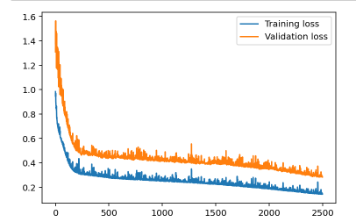
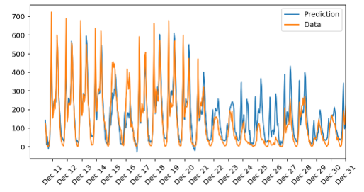
Progress: 100.0% ... Training loss: 0.257 ... Validation loss: 0.436
iterations = 3000
learning_rate = 0.1
hidden_nodes = 10
output_nodes = 1
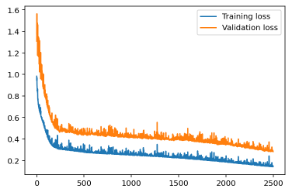
Progress: 99.8% ... Training loss: 0.810 ... Validation loss: 1.236
iterations = 500
learning_rate = 0.01
hidden_nodes = 10
output_nodes = 1

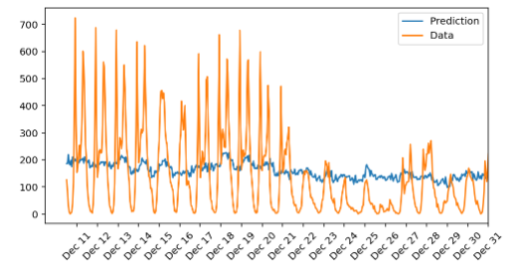
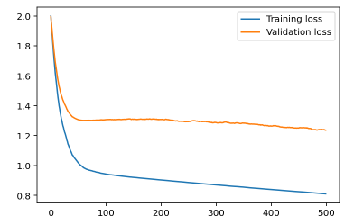

Progress: 100.0% ... Training loss: 0.237 ... Validation loss: 0.397
iterations = 5000
learning_rate = 0.1
hidden_nodes = 5
output_nodes = 1
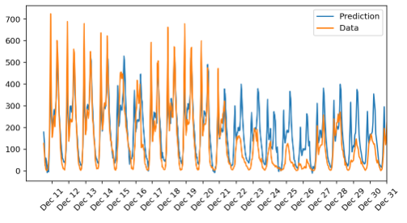
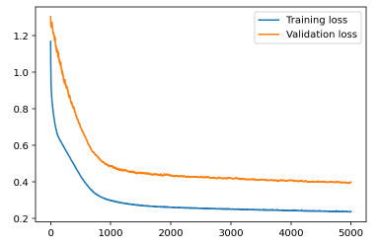
Progress: 100.0% ... Training loss: 0.224 ... Validation loss: 0.398
iterations = 5000
learning_rate = 0.1
hidden_nodes = 20
output_nodes = 1
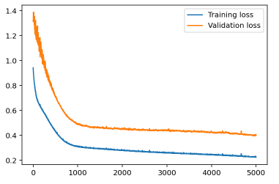
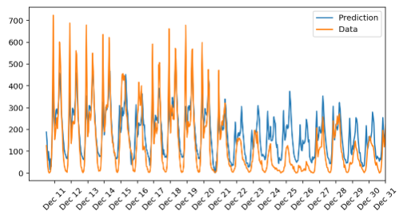
Progress: 100.0% ... Training loss: 0.460 ... Validation loss: 0.744
iterations = 5000
learning_rate = 0.01
hidden_nodes = 5
output_nodes = 1
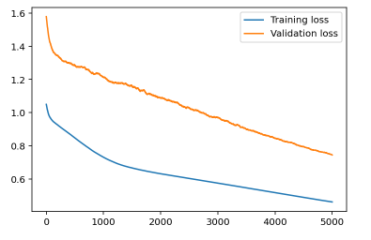
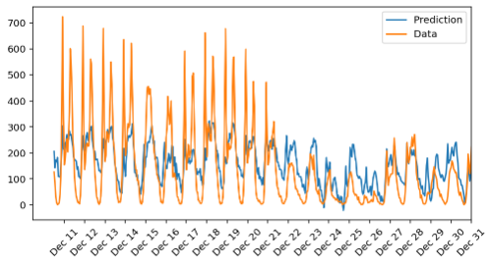

Progress: 100.0% ... Training loss: 0.065 ... Validation loss: 0.141
iterations = 5000
learning_rate = 0.5
hidden_nodes = 5
output_nodes = 1
